John Dillard Bellamy, MD Eliza McIlhenny Harriss Bellamy
b. September 18, 1817 m. June 12, 1839 b. August 6, 1821
d. August 30, 1986 d. October 18, 1907

ISSUE:

Mary Elizabeth (Belle) Bellamy
b. November 27, 1840
d. January 7, 1900

Marsden Bellamy
b. January 14, 1843
d. December 1, 1909

William (Willie) James Harriss Bellamy, MD
b. September 16, 1844
d. November 18, 1911

Eliza Bellamy
b. June 8, 1846
d. January 13, 1929

Ellen Douglas Bellamy
b. May 11, 1852
d. January 30, 1946

John Dillard Bellamy Jr.
b. March 24, 1854
d. September 25, 1942

George Harriss Bellamy
b. April 24, 1856
d. March 14, 1924

Kate Taylor Bellamy
b. June 19, 1858
d. July 14, 1858

Chesley Calhoun Bellamy
b. September 29, 1859
d. August 7, 1881

Robert Rankin Bellamy
b. July 21, 1861
d. April 7, 1926

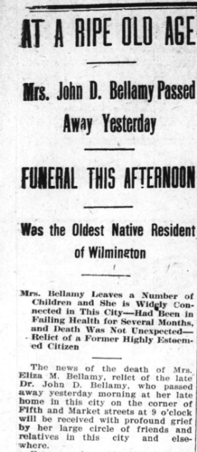
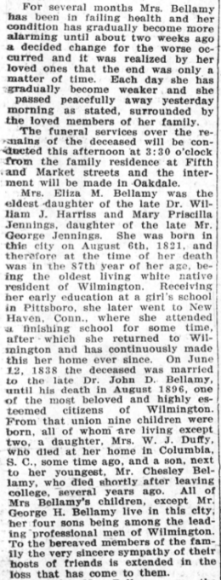
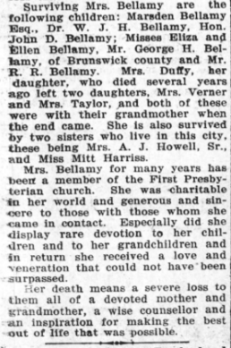
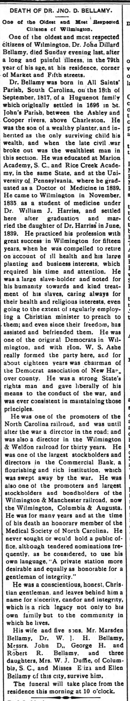
Dr. John D. Bellamy’s obituary:
The Wilmington Morning Star
Tuesday, September 1, 1896

Eliza Harriss Bellamy’s obituary:
The Wilmington Messenger
Saturday, October 19, 1907

Mary Elizabeth Bellamy Duffie’s obituary:
The Wilmington Messenger
Tuesday, January 9, 1900

Marsden Bellamy’s obituary:
The Wilmington Morning Star
Thursday, December 2, 1909

Dr. William Bellamy’s obituary:
The Wilmington Morning Star
Sunday, November 19, 1911

Ellen Bellamy’s obituary:
The Robesonian
Monday, February 4, 1946

John D. Bellamy Jr.’s obituary:
The Robesonian
Monday, September 28, 1942

George Bellamy’s obituary:
The News Reporter
Thursday, March 20, 1924

Kate Bellamy’s death announcement:
The Wilmington Journal
Friday, July 16, 1858

Chesley Bellamy’s obituary:
The Wilmington Morning Star
Tuesday, August 9, 1881

